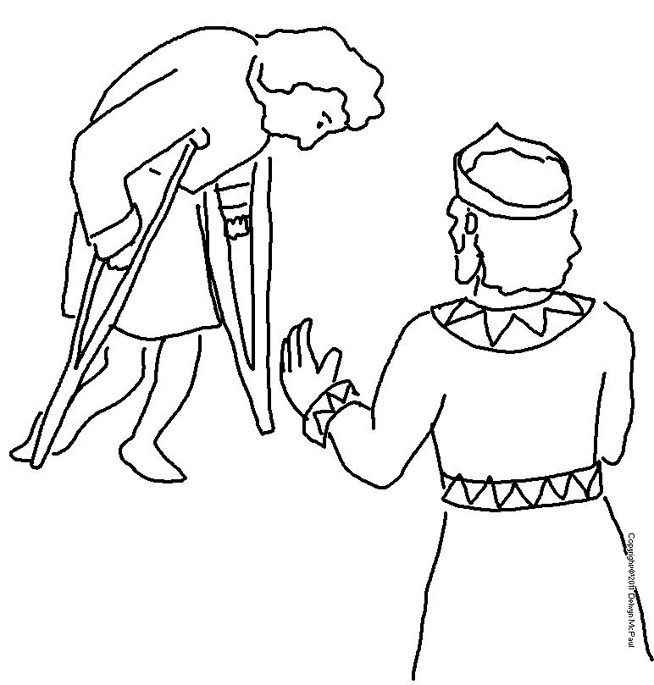

Instead, be kind to each other… forgive one another.
Ephesians 4:32 _{NLT}

